=== NETWORK FUNDAMENTALS ===
> What is Networking
> Intro To LAN
> OSI Model
> Packets & Frames

=== HOW THE WEBSITES ========
> DNS in Detail
> HTTP in Detail
> How Websites work

=== LINUX FUNDAMENTALS =====
> Linux Fundamentals 1
> Linux Fundamentals 2
> Linux Fundamentals 3

=== WINDOWS FUNDAMENTALS ===
> Windows Fundamentals 1
> Windows Fundamentals 2
> Windows Fundamentals 3

=== NETWORK FUNDAMENTALS ===
> What is Networking
> Intro To LAN
> OSI Model
> Packets & Frames

T1 > What is Networking
Networks are simply things connected. For example, your friendship circle: you are all connected because of similar interests, hobbies, skills and sorts.
Networks can be found in :
- A city's public transportation system
- Infrastructure such as the national power grid for electricity
- Meeting and greeting your neighbours
- Postal systems for sending letters and parcels
But more specifically, in computing, networking is the same idea, just dispersed to technological devices. Take your phone as an example; the reason that you have it is to access things. We'll cover how these devices communicate with each other and the rules that follow.
In computing, a network can be formed by anywhere from 2 devices to billions. These devices include everything from your laptop and phone to security cameras, traffic lights and even farming!
Networks are integrated into our everyday life. Be it gathering data for the weather, delivering electricity to homes or even determining who has the right of way at a road. Because networks are so embedded in the modern-day, networking is an essential concept to grasp in cybersecurity.
Take the diagram below as an example, Alice, Bob and Jim have formed their network! We'll come onto this a bit later on.
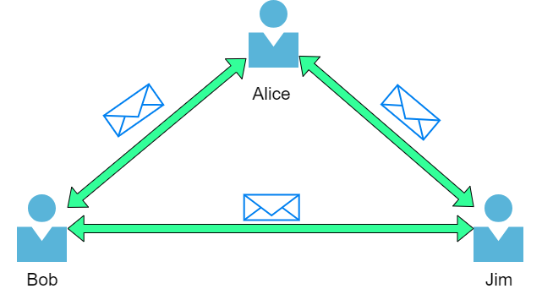
Q : What is the key term for devices that are connected together?
> Network

T2 > What is the Internet
The Internet is one giant network that consists of many, many small networks within itself. Using our example from the previous task, let's now imagine that Alice made some new friends named Zayn and Toby that she wants to introduce to Bob and Jim. The problem is that Alice is the only person who speaks the same language as Zayn and Toby. So Alice will have to be the messenger!
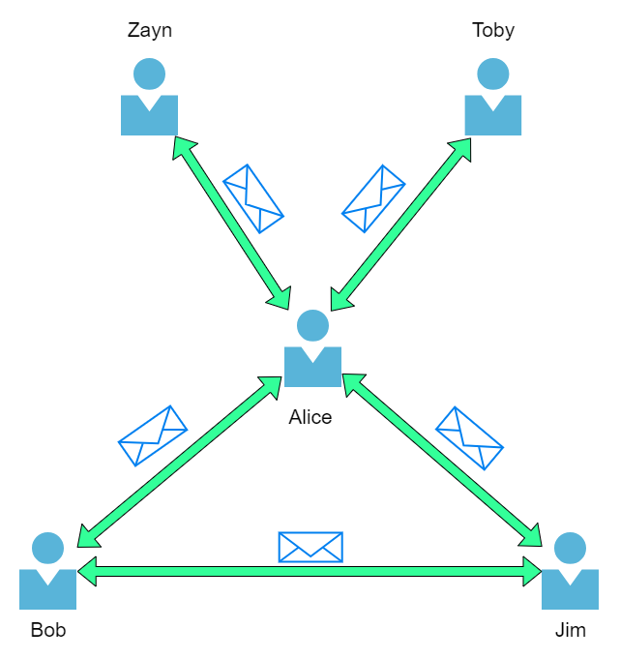
Because Alice can speak both languages, they can communicate to one another through Alice — forming a new network.
The first iteration of the Internet was within the ARPANET project in the late 1960s. This project was funded by the United States Defence Department and was the first documented network in action. However, it wasn't until 1989 when the Internet as we know it was invented by Tim Berners-Lee by the creation of the World Wide Web (WWW). It wasn't until this point that the Internet started to be used as a repository for storing and sharing information, just like it is today.
Let's relate Alice's network of friends to computing devices. The Internet looks like a much larger version of this sort of diagram:

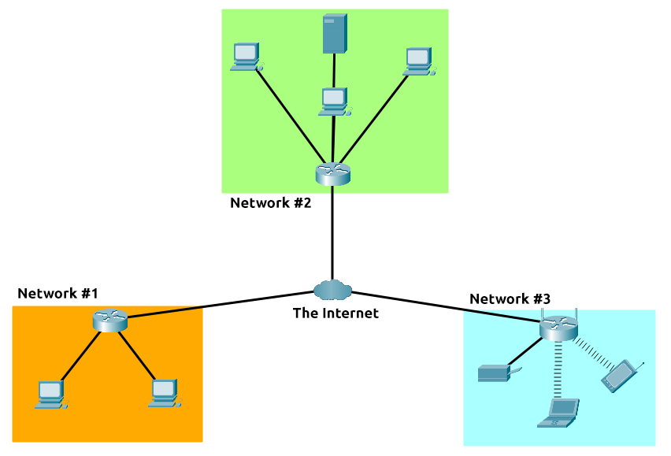
As previously stated, the Internet is made up of many small networks all joined together. These small networks are called private networks, where networks connecting these small networks are called public networks -- or the Internet! So, to recap, a network can be one of two types:
- A private network
- A public network
Devices will use a set of labels to identify themselves on a network, which we will come onto in the task below.
Q : Who invented the World Wide Web?
> Tim Berners-Lee

T3 > Identifying Devices on a network
To communicate and maintain order, devices must be both identifying and identifiable on a network. What use is it if you don't know whom you're talking to at the end of the day?
Devices on a network are very similar to humans in the fact that we have two ways of being identified:
- Our Name
- Our Fingerprints
Now we can change our name through deed poll, but we can't, however, change our fingerprints. Every human has an individual set of fingerprints which means that even if they change their name, there is still an identity behind it. Devices have the same thing: two means of identification, with one being permeable. These are:
- An IP Address
- A Media Access Control (MAC) Address -- think of this as being similar to a serial number.

IP Addresses
Briefly, an IP address (or Internet Protocol) address can be used as a way of identifying a host on a network for a period of time, where that IP address can then be associated with another device without the IP address changing. First, let's split up precisely what an IP address is in the diagram below:
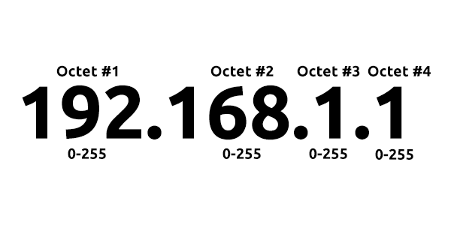
An IP address is a set of numbers that are divided into four octets. The value of each octet will summarise to be the IP address of the device on the network. This number is calculated through a technique known as IP addressing & subnetting, but that is for another day. What's important to understand here is that IP addresses can change from device to device but cannot be active simultaneously more than once within the same network.
IP Addresses follow a set of standards known as protocols. These protocols are the backbone of networking and force many devices to communicate in the same language, which is something that we'll come onto another time. However, we should recall that devices can be on both a private and public network. Depending on where they are will determine what type of IP address they have: a public or private IP address.
A public address is used to identify the device on the Internet, whereas a private address is used to identify a device amongst other devices. Take the table & screenshot below as an example. Here we have two devices on a private network:

Device Name | IP Address | IP Address Type
DESKTOP-KJE57FD | 192.168.1.77 | Private
DESKTOP-KJE57FD | 86.157.52.21 | Public
CMNatic-PC | 192.168.1.74 | Private
CMNatic-PC | 86.157.52.21 | Public

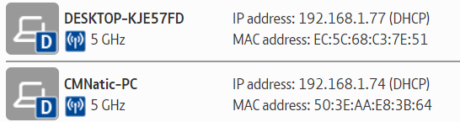

These two devices will be able to use their private IP addresses to communicate with each other. However, any data sent to the Internet from either of these devices will be identified by the same public IP address. Public IP addresses are given by your Internet Service Provider (or ISP) at a monthly fee (your bill!)
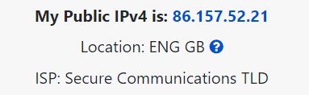
As more and more devices become connected, it is becoming increasingly harder to get a public address that isn't already in use. For example, Cisco, an industry giant in the world of networking, estimated that there would be approximately 50 billion devices connected on the Internet by the end of 2021. (Cisco., 2021). Enter IP address versions. So far, we have only discussed one version of the Internet Protocol addressing scheme known as IPv4, which uses a numbering system of 2^32 IP addresses (4.29 billion) -- so you can see why there is such a shortage!
IPv6 is a new iteration of the Internet Protocol addressing scheme to help tackle this issue. Although it is seemingly more daunting, it boasts a few benefits:
- Supports up to 2^128 of IP addresses (340 trillion-plus), resolving the issues faced with IPv4
- More efficient due to new methodologies
The screenshot below compares both an IPv6 and IPv4 address.

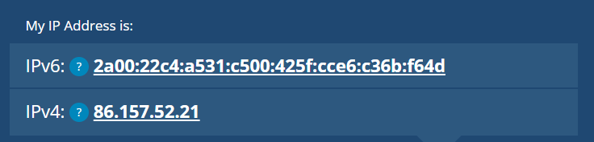

MAC Addresses
Devices on a network will all have a physical network interface, which is a microchip board found on the device's motherboard. This network interface is assigned a unique address at the factory it was built at, called a MAC (Media Access Control ) address. The MAC address is a twelve-character hexadecimal number (a base sixteen numbering system used in computing to represent numbers) split into two's and separated by a colon. These colons are considered separators. For example, a4:c3:f0:85:ac:2d. The first six characters represent the company that made the network interface, and the last six is a unique number.

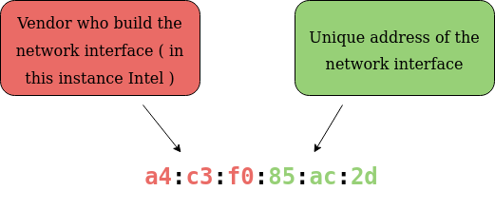
However, an interesting thing with MAC addresses is that they can be faked or "spoofed" in a process known as spoofing. This spoofing occurs when a networked device pretends to identify as another using its MAC address. When this occurs, it can often break poorly implemented security designs that assume that devices talking on a network are trustworthy. Take the following scenario: A firewall is configured to allow any communication going to and from the MAC address of the administrator. If a device were to pretend or "spoof" this MAC address, the firewall would now think that it is receiving communication from the administrator when it isn't.
Places such as cafes, coffee shops, and hotels alike often use MAC address control when using their "Guest "or "Public" Wi-Fi. This configuration could offer better services, i.e. a faster connection for a price if you are willing to pay the fee per device. The interactive lab attached to this task has been made to replicate this scenario!

Q : What does the term "IP" stand for?
> Internet Protocol
Q : What is each section of an IP address called?
> Octet
Q : How many sections (in digits) does an IP address have?
> 4
Q : What does the term "MAC" stand for?
> Media Access Control

T3 > Ping ( ICMP )
Ping is one of the most fundamental network tools available to us. Ping uses ICMP (Internet Control Message Protocol) packets to determine the performance of a connection between devices, for example, if the connection exists or is reliable.

The time taken for ICMP packets travelling between devices is measured by ping, such as in the screenshot below. This measuring is done using ICMP's echo packet and then ICMP's echo reply from the target device.

Pings can be performed against devices on a network, such as your home network or resources like websites. This tool can be easily used and comes installed on Operating Systems (OSs) such as Linux and Windows. The syntax to do a simple ping is ping IP address or website URL. Let's see this in action in the screenshot below.

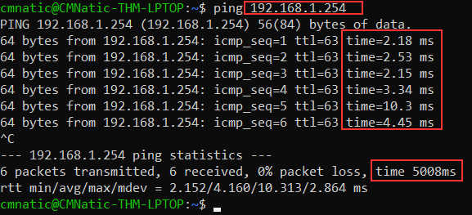

Here we are pinging a device that has the private address of 192.168.1.254. Ping informs us that we have sent six ICMP packets, all of which were received with an average time of 4.16 seconds.

Now you are going to do the same thing to ping the address of "8.8.8.8" on the deployable website in this task. Pinging the correct address will reveal a flag to answer the following question below.

Q : What protocol does ping use?
> ICMP
Q : What is the syntax to ping 10.10.10.10?
> ping 10.10.10.10

=== NETWORK FUNDAMENTALS ===
> What is Networking
> Intro To LAN
> OSI Model
> Packets & Frames

T1 > Intro to Local Area Network (LAN) Topologies
In reference to networking, when we refer to the term "topology", we are actually referring to the design or look of the network at hand. Let's discuss the advantages and disadvantages of these topologies below.

Star Topology
The main premise of a star topology is that devices are individually connected via a central networking device such as a switch or hub. This topology is the most commonly found today because of its reliability and scalability - despite the cost.
Any information sent to a device in this topology is sent via the central device to which it connects. Let's explore some of these advantages and disadvantages of this topology below:
Because more cabling & the purchase of dedicated networking equipment is required for this topology, it is more expensive than any of the other topologies. However, despite the added cost, this does provide some significant advantages. For example, this topology is much more scalable in nature, which means that it is very easy to add more devices as the demand for the network increases.
Unfortunately, the more the network scales, the more maintenance is required to keep the network functional. This increased dependence on maintenance can also make troubleshooting faults much harder. Furthermore, the star topology is still prone to failure - albeit reduced. For example, if the centralised hardware that connects devices fails, these devices will no longer be able to send or receive data. Thankfully, these centralised hardware devices are often robust.
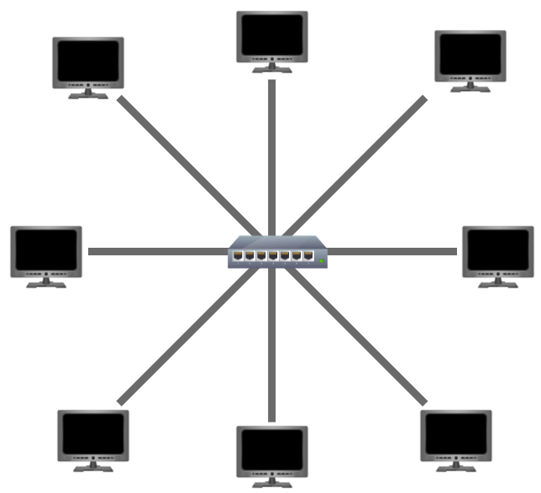

Bus Topology
This type of connection relies upon a single connection which is known as a backbone cable. This type of topology is similar to the leaf off of a tree in the sense that devices (leaves) stem from where the branches are on this cable.
Because all data destined for each device travels along the same cable, it is very quickly prone to becoming slow and bottlenecked if devices within the topology are simultaneously requesting data. This bottleneck also results in very difficult troubleshooting because it quickly becomes difficult to identify which device is experiencing issues with data all travelling along the same route.
However, with this said, bus topologies are one of the easier and more cost-efficient topologies to set up because of their expenses, such as cabling or dedicated networking equipment used to connect these devices.
Lastly, another disadvantage of the bus topology is that there is little redundancy in place in case of failures. This disadvantage is because there is a single point of failure along the backbone cable. If this cable were to break, devices can no longer receive or transmit data along the bus.
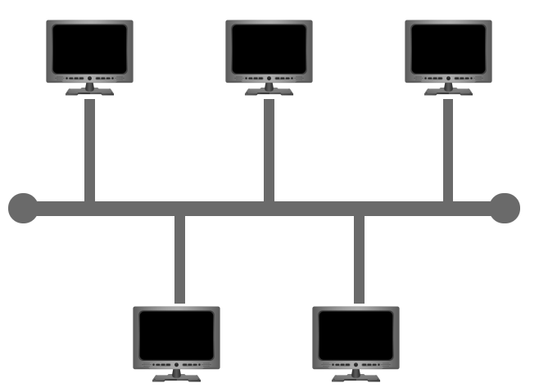

Ring Topology
The ring topology (also known as token topology) boasts some similarities. Devices such as computers are connected directly to each other to form a loop, meaning that there is little cabling required and less dependence on dedicated hardware such as within a star topology.
A ring topology works by sending data across the loop until it reaches the destined device, using other devices along the loop to forward the data. Interestingly, a device will only send received data from another device in this topology if it does not have any to send itself. If the device happens to have data to send, it will send its own data first before sending data from another device.
Because there is only one direction for data to travel across this topology, it is fairly easy to troubleshoot any faults that arise. However, this is a double-edged sword because it isn't an efficient way of data travelling across a network, as it may have to visit many multiple devices first before reaching the intended device.
Lastly, ring topologies are less prone to bottlenecks, such as within a bus topology, as large amounts of traffic are not travelling across the network at any one time. The design of this topology does, however, mean that a fault such as cut cable, or broken device will result in the entire networking breaking.
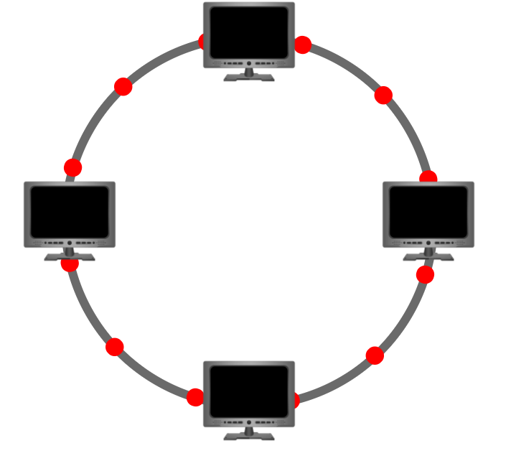
What is a Switch?
Switches are dedicated devices within a network that are designed to aggregate multiple other devices such as computers, printers, or any other networking-capable device using ethernet. These various devices plug into a switch's port. Switches are usually found in larger networks such as businesses, schools, or similar-sized networks, where there are many devices to connect to the network. Switches can connect a large number of devices by having ports of 4, 8, 16, 24, 32, and 64 for devices to plug into.
Switches are much more efficient than their lesser counterpart (hubs/repeaters). Switches keep track of what device is connected to which port. This way, when they receive a packet, instead of repeating that packet to every port like a hub would do, it just sends it to the intended target, thus reducing network traffic.
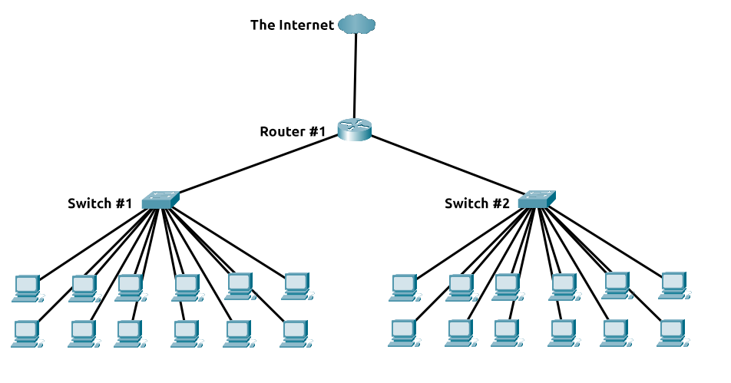

Both Switches and Routers can be connected to one another. The ability to do this increases the redundancy (the reliability) of a network by adding multiple paths for data to take. If one path goes down, another can be used. Whilst this may reduce the overall performance of a network because packets have to take longer to travel, there is no downtime -- a small price to pay considering the alternative.

What is a Router?
It's a router's job to connect networks and pass data between them. It does this by using routing (hence the name router!).
Routing is the label given to the process of data travelling across networks. Routing involves creating a path between networks so that this data can be successfully delivered.
Routing is useful when devices are connected by many paths, such as in the example diagram below.
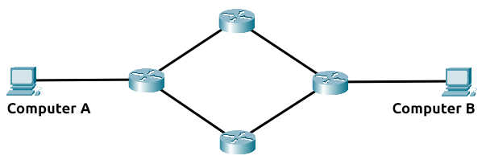

Q : What does LAN stand for?
> Local Area Network
Q : What is the verb given to the job that Routers perform?
> Routing
Q : What device is used to centrally connect multiple devices on the local network and transmit data to the correct location?
> Switch
Q : What topology is cost-efficient to set up?
> Bus Topology
Q : What topology is expensive to set up and maintain?
> Star Topology

T2 > Subnetting
Subnetting is the term given to splitting up a network into smaller, miniature networks within itself. Think of it as slicing up a cake for your friends. There's only a certain amount of cake to go around, but everybody wants a piece. Subnetting is you deciding who gets what slice & reserving such a slice of this metaphorical cake.
Take a business, for example; You will have different departments such as:
- Accounting
- Finance
- Human Resources
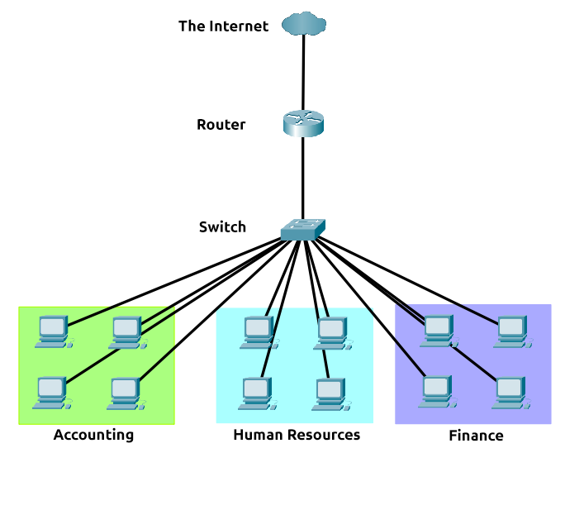
Whilst you know where to send information in real life to the correct department, networks need to know as well. Network administrators use subnetting to categorise and assign specific parts of a network to reflect this.
Subnetting is achieved by splitting up the number of hosts that can fit within the network, represented by a number called a subnet mask. Let's refer back to our diagram from the first room in this module:
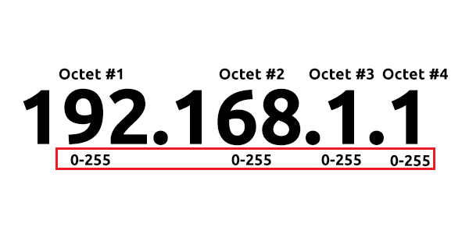
As we can recall, an IP address is made up of four sections called octets. The same goes for a subnet mask which is also represented as a number of four bytes (32 bits), ranging from 0 to 255 (0-255).
Subnets use IP addresses in three different ways:
- Identify the network address
- Identify the host address
- Identify the default gateway
Let's split these three up to understand their purposes into the table below:
Type | Purpose | Explanation | Example
Network Address | This address identifies the start of the actual network and is used to identify a network's existence. | For example, a device with the IP address of 192.168.1.100 will be on the network identified by 192.168.1.0 | 192.168.1.0
Host Address | An IP address here is used to identify a device on the subnet | For example, a device will have the network address of 192.168.1.1 | 192.168.1.100
Default Gateway | The default gateway address is a special address assigned to a device on the network that is capable of sending information to another network | Any data that needs to go to a device that isn't on the same network (i.e. isn't on 192.168.1.0) will be sent to this device. These devices can use any host address but usually use either the first or last host address in a network (.1 or .254) | 192.168.1.254
Now, in small networks such as at home, you will be on one subnet as there is an unlikely chance that you need more than 254 devices connected at one time.
However, places such as businesses and offices will have much more of these devices (PCs, printers, cameras and sensors), where subnetting takes place.
Subnetting provides a range of benefits, including:
- Efficiency
- Security
- Full control
We'll come on to explore exactly how subnetting provides these benefits at a later date; however, for now, all we need to understand is the security element to it. Let's take the typical café on the street. This cafe will have two networks:
- One for employees, cash registers, and other devices for the facility
- One for the general public to use as a hotspot
Subnetting allows you to separate these two use cases from each other whilst having the benefits of a connection to larger networks such as the Internet.

What is the technical term for dividing a network up into smaller pieces?
> Subnetting
How many bits are in a subnet mask?
> 32
What is the range of a section (octet) of a subnet mask?
> 0-255
What address is used to identify the start of a network?
> Network Address
What address is used to identify devices within a network?
> Host Address
What is the name used to identify the device responsible for sending data to another network?
> Default Gateway

T3 > The ARP Protocol
Recalling from our previous tasks that devices can have two identifiers: A MAC address and an IP address, the ARP protocol or Address Resolution Protocol for short, is the technology that is responsible for allowing devices to identify themselves on a network.
Simply, the ARP protocol allows a device to associate its MAC address with an IP address on the network. Each device on a network will keep a log of the MAC addresses associated with other devices.
When devices wish to communicate with another, they will send a broadcast to the entire network searching for the specific device. Devices can use the ARP protocol to find the MAC address (and therefore the physical identifier) of a device for communication.
How does ARP Work?
Each device within a network has a ledger to store information on, which is called a cache. In the context of the ARP protocol, this cache stores the identifiers of other devices on the network.
In order to map these two identifiers together (IP address and MAC address), the ARP protocol sends two types of messages:
- ARP Request
- ARP Reply
When an ARP request is sent, a message is broadcasted to every other device found on a network by the device, asking whether or not the device's MAC address matches the requested IP address. If the device does have the requested IP address, an ARP reply is returned to the initial device to acknowledge this. The initial device will now remember this and store it within its cache (an ARP entry).
This process is illustrated in the diagram below:

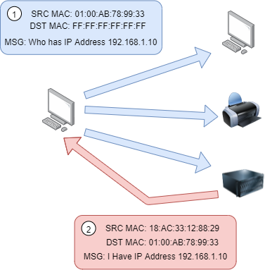
Q : What does ARP stand for?
> Address Resolutiion Protocol
Q : What category of ARP Packet asks a device whether or not it has a specific IP address?
> Request
Q : What address is used as a physical identifier for a device on a network?
> MAC address
Q : What address is used as a logical identifier for a device on a network?
> IP address

T4 > The DHCP Protocol
IP addresses can be assigned either manually, by entering them physically into a device, or automatically and most commonly by using a DHCP (Dynamic Host Configuration Protocol) server. When a device connects to a network, if it has not already been manually assigned an IP address, it sends out a request (DHCP Discover) to see if any DHCP servers are on the network. The DHCP server then replies back with an IP address the device could use (DHCP Offer). The device then sends a reply confirming it wants the offered IP Address (DHCP Request), and then lastly, the DHCP server sends a reply acknowledging this has been completed, and the device can start using the IP Address (DHCP ACK).
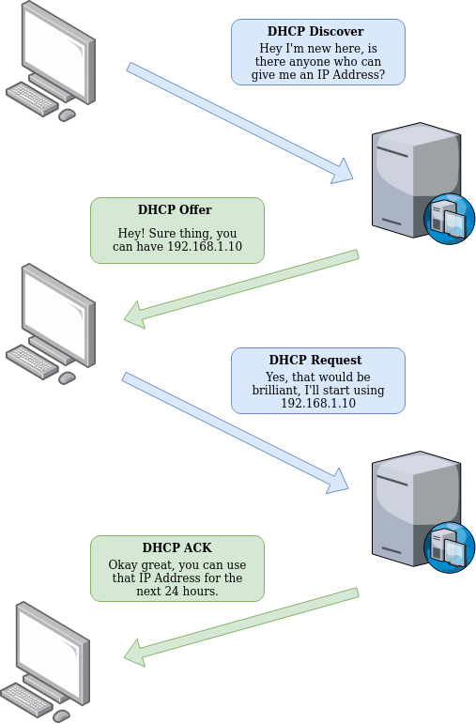

What type of DHCP packet is used by a device to retrieve an IP address?
> DHCP discover
What type of DHCP packet does a device send once it has been offered an IP address by the DHCP server?
> DHCP request
Finally, what is the last DHCP packet that is sent to a device from a DHCP server?
> DHCP ack

=== NETWORK FUNDAMENTALS ===
> What is Networking
> Intro To LAN
> OSI Model
> Packets & Frames

T1 > What is OSI model
The OSI model (or Open Systems Interconnection Model) is an absolute fundamental model used in networking. This critical model provides a framework dictating how all networked devices will send, receive and interpret data.

One of the main benefits of the OSI model is that devices can have different functions and designs on a network while communicating with other devices. Data sent across a network that follows the uniformity of the OSI model can be understood by other devices.

The OSI model consists of seven layers which are illustrated in the diagram below. Each layer has a different set of responsibilities and is arranged from Layer 7 to Layer 1.

At every individual layer that data travels through, specific processes take place, and pieces of information are added to this data, which is what we’ll come to discuss in the upcoming tasks within this room. However, for now, we only need to understand that this process is called encapsulation and what the OSI model looks like in the diagram below:
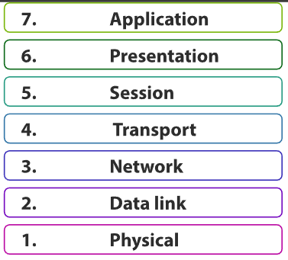
Q : What does the “OSI” in “OSI Model” stand for?
> Open Systems Interconenction
Q : How many layers (in digits) does the OSI model have?
> 7
Q : What is the key term for when pieces of information get added to data?
> Encapsulation

T2 > Layer 7 - Application
The application layer of the OSI model is the layer that you will be most familiar with. This familiarity is because the application layer is the layer in which protocols and rules are in place to determine how the user should interact with data sent or received.
Everyday applications such as email clients, browsers, or file server browsing software such as FileZilla provide a friendly, Graphical User Interface (GUI) for users to interact with data sent or received. Other protocols include DNS (Domain Name System), which is how website addresses are translated into IP addresses.

Q : What is the technical term that is given to the name of the software that users interact with?
> Graphical User Interface

T3 > Layer 6 - Presentation
Layer 6 of the OSI model is the layer in which standardisation starts to take place. Because software developers can develop any software such as an email client differently, the data still needs to be handled in the same way — no matter how the software works.
This layer acts as a translator for data to and from the application layer (layer 7). The receiving computer will also understand data sent to a computer in one format destined for in another format. For example, when you send an email, the other user may have another email client to you, but the contents of the email will still need to display the same.
Security features such as data encryption (like HTTPS when visiting a secure site) occur at this layer.

Q : What is the main purpose that this Layer acts as?
> Translator

T4 > Layer 5 - Session
Once data has been correctly translated or formatted from the presentation layer (layer 6), the session layer (layer 5) will begin to create a connection to the other computer that the data is destined for. When a connection is established, a session is created. Whilst this connection is active, so is the session.

The session layer (layer 5) synchronises the two computers to ensure that they are on the same page before data is sent and received. Once these checks are in place, the session layer will begin to divide up the data sent into smaller chunks of data and begin to send these chunks (packets) one at a time. This dividing up is beneficial because if the connection is lost, only the chunks that weren’t yet sent will have to be sent again — not the entire piece of the data (think of it as loading a save file in a video game).

What is worthy of noting is that sessions are unique — meaning that data cannot travel over different sessions, but in fact, only across each session instead.

Q : What is the technical term for when a connection is successfully established?
> Session
Q : What is the technical term for “small chunks of data”?
> Packets
Q : What is the technical term for when a connection is successfully established?
> Session

T5 > Layer 4 - Transport
Layer 4 of the OSI model plays a vital part in transmitting data across a network and can be a little bit difficult to grasp. When data is sent between devices, it follows one of two different protocols that are decided based upon several factors:
- TCP
- UDP
Let’s begin with TCP. The Transmission Control Protocol (TCP). Potentially hinted by the name, this protocol is designed with reliability and guarantee in mind. This protocol reserves a constant connection between the two devices for the amount of time it takes for the data to be sent and received.

Not only this, but TCP incorporates error checking into its design. Error checking is how TCP can guarantee that data sent from the small chunks in the session layer (layer 5) has then been received and reassembled in the same order.
Advantages of TCP | Disadvantages of TCP
Guarantees the accuracy of data. | Requires a reliable connection between the two devices. If one small chunk of data is not received, then the entire chunk of data cannot be used.
Capable of synchronising two devices to prevent each other from being flooded with data. | A slow connection can bottleneck another device as the connection will be reserved on the receiving computer the whole time.
Performs a lot more processes for reliability. | TCP is significantly slower than UDP because more work has to be done by the devices using this protocol.
TCP is used for situations such as file sharing, internet browsing or sending an email. This usage is because these services require the data to be accurate and complete (no good having half a file!).

In the diagram below, we can see how a picture of a dog is broken down into small pieces of data (known as packets) from the “webserver”, where the “computer” re-constructs the picture of the dog into the correct order.
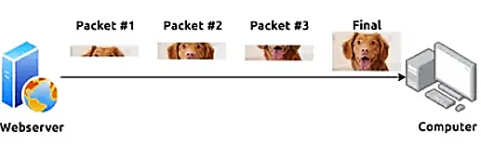
Now let’s move onto the User Datagram Protocol (or UDP for short). This protocol is not nearly as advanced as its brother – the TCP protocol. It doesn’t boast the many features offered by TCP, such as error checking and reliability. In fact, any data that gets sent via UDP is sent to the computer whether it gets there or not. There is no synchronisation between the two devices or guarantee; just hope for the best, and fingers crossed.
Advantages of UDP | Disadvantages of UDP
UDP is much faster than TCP. | UDP doesn’t care if the data is received.
UDP leaves the application layer (user software) to decide if there is any control over how quickly packets are sent. | It is quite flexible to software developers in this sense.
UDP does not reserve a continuous connection on a device as TCP does. | This means that unstable connections result in a terrible experience for the user.

Using the same example as before, we can now see that only Packets #1 and #3 have been received by the “Computer”, meaning that half of the image is missing.
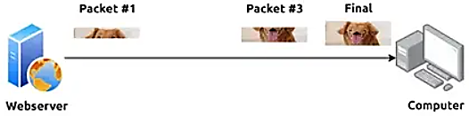

UDP is useful in situations where there are small pieces of data being sent. For example, protocols used for discovering devices (ARP and DHCP that we discussed in Room 2 – Intro to LAN) or larger files such as video streaming (where it is okay if some part of the video is pixelated. Pixels are just lost pieces of data!)

Q : What does TCP stand for?
> Transmission Control Protocol
Q : What does UDP stand for?
> User Datagram Protocol
Q : What protocol guarantees the accuracy of data?
> TCP
Q : What protocol doesn’t care if data is received or not by the other device?
> UDP
Q : What protocol would an application such as an email client use?
> TCP

Q : What protocol would an application that downloads files use?
> TCP
Q : What protocol would an application that streams video use?
> UDP

T6 > Layer 3 - Network
The third layer of the OSI model (network layer) is where the magic of routing & re-assembly of data takes place (from these small chunks to the larger chunk). Firstly, routing simply determines the most optimal path in which these chunks of data should be sent.
Whilst some protocols at this layer determine exactly what is the “optimal” path that data should take to reach a device, we should only know about their existence at this stage of the networking module. Briefly, these protocols include OSPF (Open Shortest Path First) and RIP (Routing Information Protocol). The factors that decide what route is taken is decided by the following:
- What path is the shortest? I.e. has the least amount of devices that the packet needs to travel across.
- What path is the most reliable? I.e. have packets been lost on that path before?
- Which path has the faster physical connection? I.e. is one path using a copper connection (slower) or a fibre (considerably faster)?
At this layer, everything is dealt with via IP addresses such as 192.168.1.100. Devices such as routers capable of delivering packets using IP addresses are known as Layer 3 devices — because they are capable of working at the third layer of the OSI model.
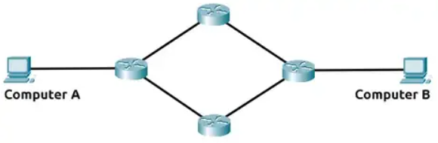
Q : Will packets take the most optimal route across a network? (Y/N)
> Y
Q : What does the acronym “OSPF” stand for?
> Open Shortest Path First
Q : What does the acronym “RIP” stand for?
> Routing Information Prot
Q : What type of addresses are dealt with at this layer?
> IP Addresses

